Day 13 Assignment

Name: Mehul Anjikhane Email: mehulanjikhane13@gmail.com

**Task 1: Data Types/Variables**

**Write a program that declares two integer variables, swaps their values without using a third variable, and prints the result.**

**package** assignments;

**public** **class** VariableSwap {

**public** **static** **void** main(String[] args) {

// **TODO** Auto-generated method stub

**int** num1 = 25, num2 = 30;

System.***out***.println("Before Swappping: Num1 = " + num1 + ", Num2 = " + num2);

num2 = num1+num2;

num1 = num2-num1;

num2 = num2-num1;

System.***out***.println("After Swappping: Num1 = " + num1 + ", Num2 = " + num2);

}

}

**Output:**

Before Swappping: Num1 = 25, Num2 = 30

After Swappping: Num1 = 30, Num2 = 25

**Task 2: Operators**

**Create a program that simulates a simple calculator using command-line arguments to perform and print the result of addition, subtraction, multiplication, and division.**

**package** assignments;

**import** java.util.Scanner;

**public** **class** SimpleCalculator {

**public** **static** **void** main(String[] args) {

// **TODO** Auto-generated method stub

**double** num1, num2;

**char** operator;

Scanner input = **new** Scanner(System.***in***);

System.***out***.println("Enter first number:");

num1 = input.nextDouble();

System.***out***.println("Enter second number:");

num2 = input.nextDouble();

System.***out***.println("Choose an operation(+,-,*,/): ");

operator = input.next().charAt(0);

**switch**(operator) {

**case**'+': System.***out***.printf("%.2f + %.2f = %.2f",

num1,num2,num1+num2);

**break**;

**case**'-': System.***out***.printf("%.2f - %.2f = %.2f",

num1,num2,num1-num2);

**break**;

**case**'*': System.***out***.printf("%.2f * %.2f = %.2f",

num1,num2,num1*num2);

**break**;

**case**'/':

**if**(num2 != 0)

System.***out***.printf("%.2f / %.2f = %.2f",

num1,num2,num1/num2);

**else**

System.***out***.println("Division by zero is not allowed.");

**break**;

**default**: System.***out***.println("Inavalid operator! Please enter correct one.");

}

input.close();

}

}

**Output in CMD:**

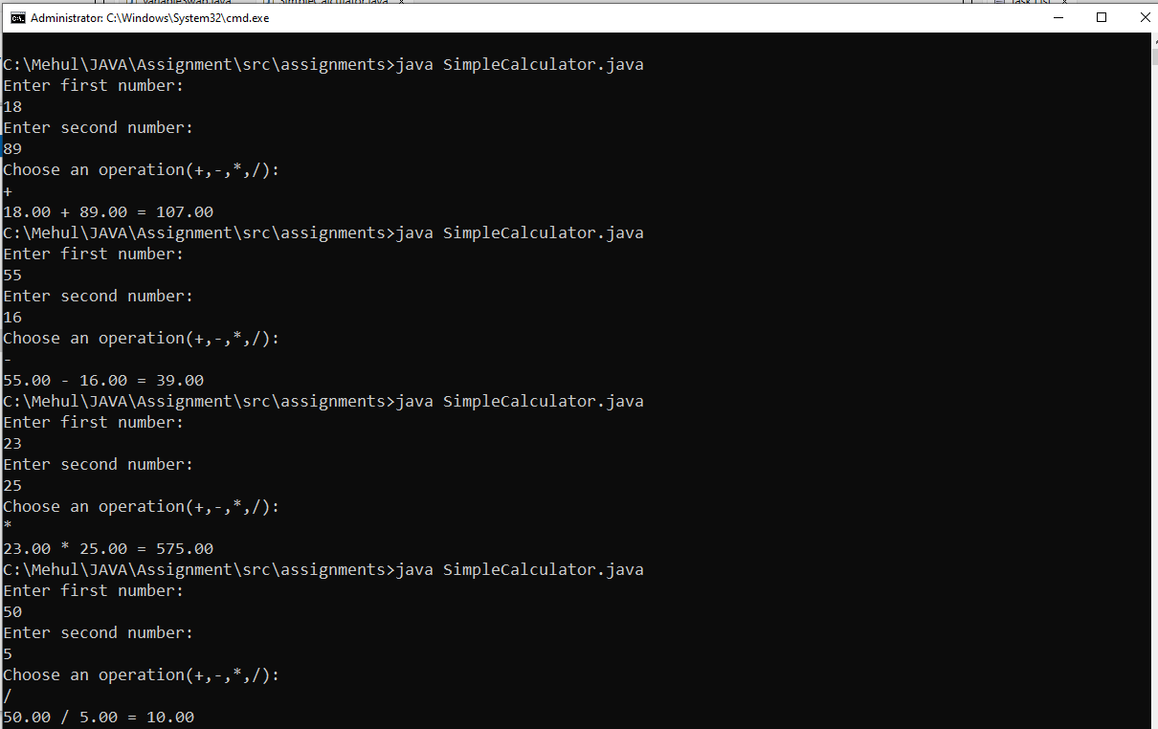

**Task 3: Control Flow**

**Write a Java program that reads an integer and prints whether it is a prime number using a for loop and if statements.**

**package** assignments;

**import** java.util.Scanner;

**public** **class** CheckPrimeNumber {

**public** **static** **void** main(String[] args) {

// **TODO** Auto-generated method stub

Scanner sc = **new** Scanner(System.***in***);

System.***out***.print("Enter an number:");

**int** num = sc.nextInt();

**if**(*isPrime*(num))

System.***out***.println(num + " is a Prime Number.");

**else**

System.***out***.println(num + " is not a Prime Number.");

sc.close();

}

**private** **static** **boolean** isPrime(**int** num) {

**if**(num <= 1)

**return** **false**;

**else** {

**for**(**int** i = 2; i <= Math.*sqrt*(num); i++) {

**if**(num % i == 0 ) {

**return** **false**;

}

}

}

**return** **true**;

}

}

**Output:**

Enter an number:23

23 is a Prime Number.

Enter an number:25

25 is not a Prime Number.

**Task 4: Constructors**

**Implement a Matrix class that has a constructor which initializes the dimensions of a matrix and a method to fill the matrix with values.**

**package** assignments;

**import** java.util.Scanner;

**public** **class** Matrix {

**private** **int** rows;

**private** **int** columns;

**private** **int**[][] matrix;

**public** Matrix(**int** rows, **int** columns){

**super**();

**this**.rows = rows;

**this**.columns = columns;

**this**.matrix = **new** **int**[rows][columns];

}

**public** **void** fillmatrix() {

Scanner sc = **new** Scanner(System.***in***);

System.***out***.println("Enter the elements of matrix: ");

**for**(**int** i = 0; i < rows; i++) {

**for**(**int** j = 0; j < columns; j++) {

matrix[i][j] = sc.nextInt();

}

}

sc.close();

}

**public** **void** displayMatrix() {

System.***out***.println("The matrix is: ");

**for**(**int** i = 0; i < rows; i++) {

**for**(**int** j = 0; j < columns; j++) {

System.***out***.print(matrix[i][j] + " ");

}

System.***out***.println();

}

}

**public** **static** **void** main(String[] args) {

Matrix m = **new** Matrix(2, 3);

m.fillmatrix();

m.displayMatrix();

}

}

**Output:**

Enter the elements of matrix:

15

52

46

28

3

96

The matrix is:

15 52 46

28 3 96

**Task 5: Inheritance**

**Create a Shape class with a method area() and extend it with Circle and Rectangle classes overriding the area() method appropriately.**

**package** assignments;

**public** **class** Shape {

**public** **double** area() {

**return** 0;

}

}

**class** Circle **extends** Shape{

**private** **double** radius;

**public** Circle(**double** radius) {

**super**();

**this**.radius = radius;

}

@Override

**public** **double** area() {

**return** Math.***PI*** * radius * radius;

}

}

**class** Rectangle **extends** Shape{

**private** **double** length, width;

**public** Rectangle(**double** length, **double** width) {

**super**();

**this**.length = length;

**this**.width = width;

}

@Override

**public** **double** area() {

**return** length * width;

}

}

**public** **class** TestShape{

**public** **static** **void** main(String[] args) {

// **TODO** Auto-generated method stub

Shape circle = **new** Circle(7);

System.***out***.println("Area of circle: " + circle.area());

Shape rectangle = **new** Rectangle(8, 6);

System.***out***.println("Area of Rectangle: " + rectangle.area());

}

}

**Output:**

Area of Circle: 153.93804002589985

Area of Rectangle: 48.0